Campaigning for the rights of older people
**NEWS – Immediate Release**

NPC asks how older people can get new Test & Trace App when they don’t have smartphones
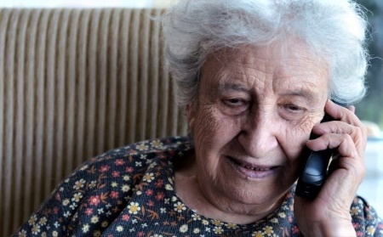

The National Pensioners’ Convention has asked the chair of the Government’s Covid-19 test and trace programme what provision is being made for older people who do not have smartphones.
The new programme relies on the public downloading an app to their smartphones to track the spread of Coronavirus. However, more than 60% of those over 65 do not have smartphones(*ONS). The percentage for over 75’s - those most at risk from Coronavirus - is even higher, which means most older people will be excluded from taking part in the programme.
NPC General Secretary Jan Shortt has written to Baroness Dido Harding, who is leading the NHS test and trace roll-out, to ask that ‘older people will not be forgotten’ in her plans.
Jan said: “We are concerned about the communication around the test and trace app that is intended to be an indicator of when an individual may have come into contact with another individual testing positive for the virus.
“We are wondering if you have made (or will you be making) any provision for older people who do not have a smartphone (or in lots of cases not even a mobile phone), given that we are in a ‘high risk’ category?”
Jan explained that although she herself has a laptop and a tablet, her mobile phone – like those owned by many older people - is ‘pay as you go’ for use in an emergency or for contacting family and friends, because she cannot afford a smartphone or the data charges.
She said: “Technology is a wonderful thing, but to many older people (who choose not to go online) it brings worries of fraud, hacking and other elements they have little or no understanding of, and therefore if the government is to rely on test and trace, it has to be across the board in different forms to keep everyone safe.”
ENDS
For more information or to interview Jan Shortt please contact:

Beverley Morrison
Campaign & Media Officer

National Pensioners Convention
​Telephone: 0208 425 2367 or 07588 779515
bevmorrison@npcuk.org or info@npcuk.org

* Office for National Statistics, 2019.
**The National Pensioners Convention was set up in 1979 to champion the rights and welfare of the UK’s older people. It now represents more than 1.5 million people in over 1,000 different organisations across the UK and holds an annual Pensioners’ Parliament to debate issues affecting older people.
www.npcuk.org

